Gypfine High Coat
Gypfine High Coat is a thick smoothing plaster for rough substrates in the form of whitish powder, ready for manual application after the addition of the specific amount of water. It’s mechanically mixed and automatically packed with constant tested ratios, composed from primary raw materials and high quality additives enhancing the product performance. Natural elements compose more than 98% from the total weight. After adding the right portion of clean water, it gives homogeneous mortar ready for application without adding any additives. This is product has the ability to act as a first thick smoothing coat for rough substrates either Gyplast Fill or traditional sand & cement plaster to repair it in order to reach the required linning.
Gypfine High Coat after its setting gives a hard and smooth coat. It also features a very high adhesion to different types of substrates especially with lowest percentage of waste.
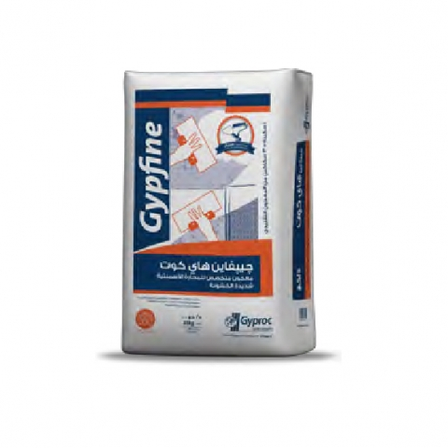

Key facts
- Perfect repair for traditional Sand and Cement especially the very rough substrates
- Gives a Very hard smooth whitish surface
- Must be finished with Gypfine Almomtaz 120 or Gypfine Super Almomtaz on top of it to prepare surfaces for paints
- Average coverage rate (Lab trials ) reaching 10 - 10.75 m²/sack at 3 mm thickness, according to type and roughness of substrates
- Easy to prepare, only spray the powder to the indicated ratio of water then mix thoroughly till reaching the required consistency
- Setting time 60 minutes according to storage and application conditions
- Optimum for large areas because after setting Gypfine High Coat doesn’t show the jointing between different areas applied on a long interval of time making it perfect for repairs and maintenance
- At the end, the final surface is a whitish, strong and decorative rough texture

Application

Before starting
Substrate must be sound, free from dust, loose particles, cement laitance, curing compounds, oil, grease or any other contamination.
Ensure the mixing container and the application tools are clean especially form waste of previous mix and it’s recommended to clean the tools directly after usage.

Preparation
Gypfine High Coat is prayed on water with the right ratios (Don’t add water to powder), then leave for 2 minutes till it soaks completely. Stir the mix perfectly in all directions till reaching homogeneous mortar with the convenient consistency for the application. It is preferred to use mechanical mixing
Gypfine High Coat is workable for 60 minutes starting from the start of mixing, initial setting in 60-70 minutes and reaches final setting in 1 day on average according to surface conditions, and thickness, weather conditions and humidity.

Technical data
Item | Specification
Fineness | 11 - 13% retained on sieve 200 mic.  16 - 23% retained on sieve 100 mic.
Final Setting time | 60 - 70 minutes
Working time | 40 -50 minutes
Water Plaster ratio | 88 ml/100 gm.
Water retention ratio | 97 – 99.5 %.
Consistency | 165 mm. ±5
Slurry density | 1415 - 1460 gm./mm³ (± 0.02)
Flexural strength | ≥ 1 N/mm²
Compressive strength | ≥ 1 N/mm²
Adhesive strength (pull out) | ≥0.2 N/mm²
Hardness | ≥3.5 N/mm²
Lab coverage/ ton | 400 – 430 m² @ 3 mm. thickness

Storage & Packing:
Gypfine High Coat is supplied in 25KG paper sacks constructed in three layers; the innermost layer is brown paper, the outermost layer is white paper, and a plastic layer in the middle.
The construction of the sacks ensures that the contents will be protected adequately under normal conditions of transport, storage and handling.
- Packs /Ton: 40 sacks

Storage Conditions:
Must be stored in a dry area away from the reach of humidity or any water source, preferably on wooden pallets and covered with impermeable cover to maintain a steady quality the longest duration possible
- Storage Validity: 1 Year

Standard:
Gypsum Building Plaster (B4) with an initial setting time > 20 minutes and compressive strength ≥ 6 N/mm²
GYPSUM BUILDING PLASTER
EN 13279-1 – B4/20/6

