Gypfine Almomtaz 120
Gypfine Almomtaz 120 is a high quality white putty used as a base for painting works and a decorative textured layer. It also gives a high smooth glossy surface. Ready for manual application after the addition of the specific amount of water. It’s mechanically mixed and automatically packed with constant tested ratios, composed from primary raw materials and high quality additives enhancing the product performance. Natural elements compose 98% of the total weight. After adding the right portion of clean water, it gives a homogeneous putty ready for application without any further additives.
Gypfine Almomtaz 120 to be used as a base coat prior Gypfine Super Almomtaz or any ready mix putty then painting for interior application onto the fair-face concrete and Sand & Cement substrates.
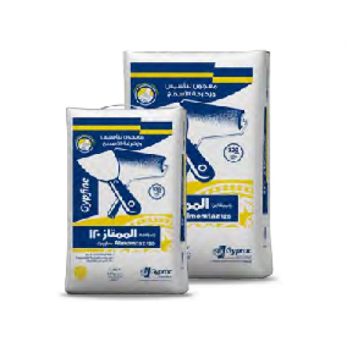

Key facts

Gypfine Almomtaz 120 is used as:
- A base coat prior Gypfine Super Almomtaz then painting for interior application onto the fair-face concrete and Sand & Cement substrates
- Final coat with different texture
- To prepare the surface of Gypsum boards before painting
- Used directly onto the fair-faced concrete without any mechanical preparations

Application

Before starting:
Substrate must be sound, free from dust, loose particles, cement laitance, curing compounds, oil, grease or any other contamination.
Ensure the mixing container and the application tools are clean especially form waste of previous mix and it’s recommended to clean the tools directly after usage.

Preparation:
Gypfine Almomtaz 120 is prayed on water with the right ratios (Don’t add water to powder), then leave for 2 minutes till it soaks completely. Stir the mix perfectly in all directions till reaching a homogeneous mortar with the convenient consistency for the application. It is preferred to use mechanical mixing

Gypfine Almomtaz 120 is workable for 100 minutes starting from the start of mixing, initial setting in 120 minutes and reaches final setting in 1 day on average according to surface conditions, and thickness, weather conditions and humidity.

Item
Flexural Strength | ≥1.0 N/mm²
Workability Time | 100 minutes
Initial time | 120 minutes
Setting time | 100 minutes
Adhesive strength | ≥0.2 N/mm²
Surface Hardness | ≥3.5 N/mm²
Coverage / Sac | 1-1.2 m² per 1 KG powder @ 1 mm thickness
% Mixing water | 75 - 85 %
Max. Thickness / Layer | 2-3 mm/ Coat

Storage & Packing:
Gypfine Almomtaz 120 is supplied in 12KG handy and 25KG paper sacks constructed in three layers; the innermost layer is brown paper, the outermost layer is white paper, and a plastic layer in the middle.
The construction of the sacks ensures that the contents will be protected adequately under normal conditions of transport, storage and handling.

- Pack: 12 KG - 25 KG
- Packs / Ton: 83 sacks / ton - 40 sacks/ ton

Storage Conditions:
Must be stored in a dry area away from the reach of humidity or any water source, preferably on wooden pallets and covered with impermeable cover to maintain a steady quality the longest duration possible
- Storage Validity: 1 year from production date

Standard:
Gypsum Building Plaster (B1) with an initial setting time > 20 min and compressive strength ≥ 2,0 N/mm2
GYPSUM BUILDING PLASTER
EN 13279-1 – B1/20/2

